1. Suppose, you are working as a software architect for a mid-sized financial technology company. The company is developing a new platform called FinMaster, which aims to provide personal finance management solutions to end-users.
Backend Services subsystem has five internal components: User Management, Budgeting-Expense, Investment Portfolio, External API Integration, and Data Storage. The User Management component has two provided interfaces: iUserAuthService for user authentication and iAccessControlService for access control and role management. The budgeting-Expense component interacts with the User Management component to retrieve user information and access control using required interface iAccessControlService. This component also depends on the iDataStorageService interface which is provided by the Data Storage component to store and retrieve budget data. Similar to the Budgeting-Expense component, the Investment Portfolio component retrieves user information from the User Management component using the required interface iAccessControlService and depends on the iDataStorageService interface for persisting portfolio information. External API Integration component communicates with external Bank component to retrieve transaction data using its required interface iBankIntegration. The Bank component has another required interface iUserAuthService. Delegation connectors link these external contracts of the subsystem to the realization of the contracts by User Management and External API Integration components. Both Budgeting-Expense and Investment Portfolio components use the ITransactionUpdate interface provided by the External API Integration component for retrieving transaction updates that are used in budgeting and portfolio analysis. The User Management component has a dependency on the External API Integration component to authenticate a user or verify their identity.

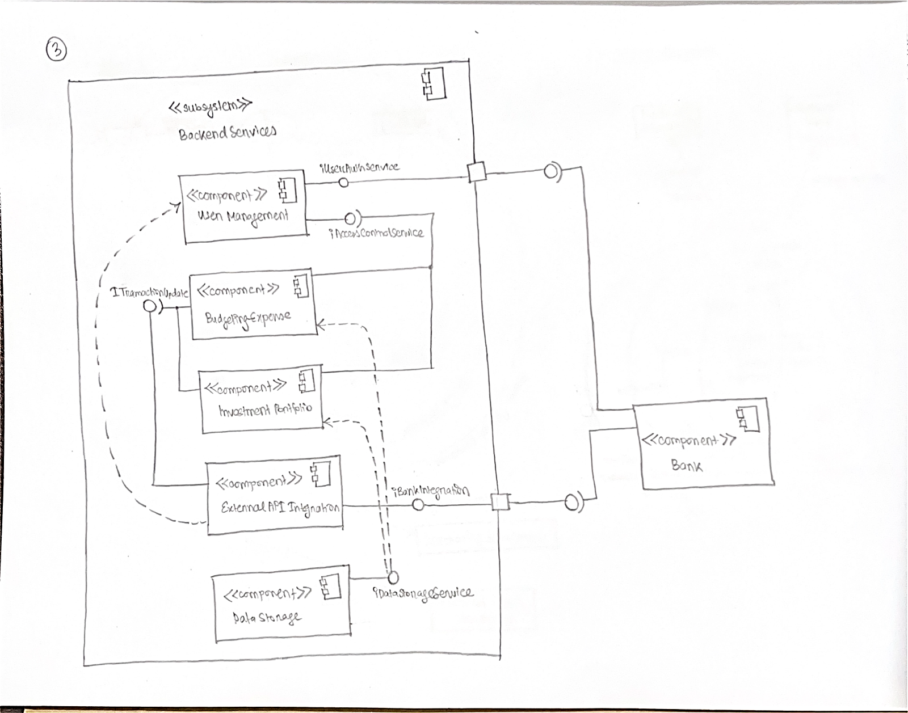
2. Suppose you are developing an e-commerce platform called "ShopifyPlus," aimed at providing a robust and scalable solution for businesses of all sizes. The platform leverages various components across the enterprise, and as an architect, you utilize UML component diagrams to describe the application architecture. The "Order Management" component is a component of the ShopifyPlus subsystem which serves as a backbone, orchestrating the entire order processing workflow. The component offers two crucial interfaces: "OrderEntry" and "ProcessedOrder." Both interfaces are required by the "Enterprise Front Office System" component, enabling seamless integration with the front-end systems of businesses. Additionally, the "Order Management" component relies on external services to fulfill its functionalities: An external "Legacy Integration" component provides the "LegacyData" interface, allowing ShopifyPlus Data Storage Component to integrate with legacy systems and retrieve historical data. An internal "Inventory Management" component offers the "Inventory" interface, enabling real-time inventory updates and stock management. A "Payment Gateway" component facilitates secure payment processing by providing the "Payment" interface. Furthermore, the platform interfaces with external companies through the "External Partners Integration" subsystem, consisting of two components: "Supplier A" component provides the "SAIntegration" interface. "Supplier B" component provides the "SBIntegration" interface. Delegation connectors link the external contracts of the External Partners Integration subsystem. Moreover, two critical components are integrated into the tracking subsystem: The "Shipping Integration" component provides shipping-related functionalities through the "Shipping" interface. The "Customer Support Portal" component enables seamless customer support interactions by offering the "Support" interface. Finally, the "Data Warehouse" component aggregates and stores order-related data for reporting and analytics purposes, leveraging the "DataStore" interface provided by the "Data Storage" component through a delegation connector.

Now, draw a Component Diagram based on the above scenario.
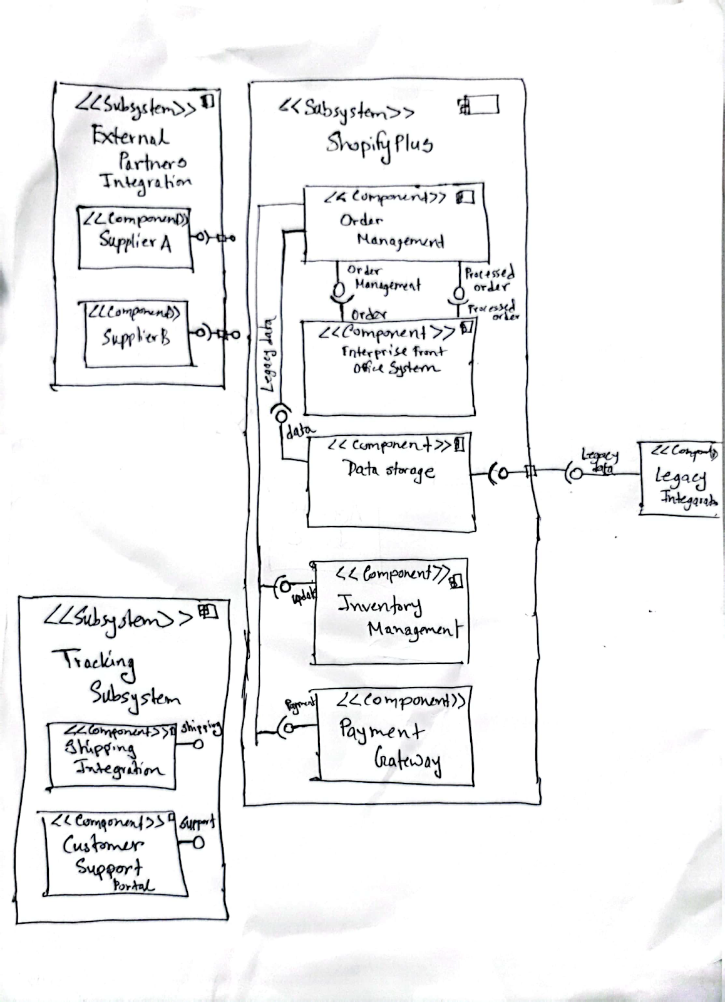

3. As the lead software architect at EduLearn Systems, you are tasked with designing a next-generation online course platform focusing on modularity and efficient data processing. The platform is divided into three subsystems: Client Subsystem, Server Subsystem, and External API Manager Subsystem. The Client Subsystem includes the User Dashboard Component, which provides the UserActivity interface to the Client Session Manager Component. The Client Session Manager Component provides the SessionControl interface, required by the Course Delivery Component in the Server Subsystem to synchronize content delivery. It also requires the AuthenticationProtocol interface provided by the Authentication Server Component in the Server Subsystem for user authentication.

In the Server Subsystem, the Server Session Manager Component provides the SessionValidation interface required by the Course Delivery Component and uses the ContentSync interface provided by the Content Database Component for course content updates. The Content Database Component supplies course content to the Course Delivery Component through the ContentFetch interface and depends on the ResourceUpdates interface provided by External API Manager Subsystem’s External API Manager Component to update its content.

The External API Manager Subsystem contains the External API Manager Component which provides the ThirdPartyData interface to the Course Delivery Component for enriching course content. Also, have a dependency on the insights interface provided by the User dashboard.
Additionally, the Analytics Engine Component provides the Insights interface to the User Dashboard Component, upon receiving progress data from the ProgressData interface of the Course Delivery Component.

Draw a component diagram based on the above scenario.

